2200030216 WEEK-4 spring-rest-handson

TASK-3 Hello World RESTful Web Service

HERE WE RUN THE CODE IN THE TERMINAL WITH THE COMMAND

mvn spring:boot:run

we used port 8083

you will see the output on the postman at GET using this link

http://localhost:8083/hello

or you can use the same link on chrome or edge to see the output

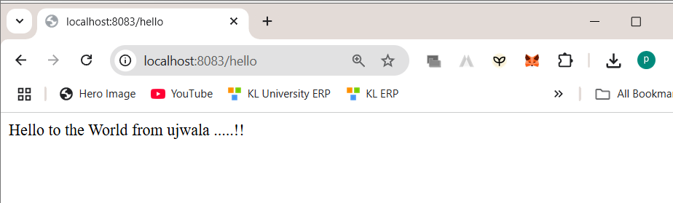

Hellocontroller.java

package com.cognizant.spring_learn.controller;

import org.slf4j.Logger;

import org.slf4j.LoggerFactory;

import org.springframework.web.bind.annotation.*GetMapping*;

import org.springframework.web.bind.annotation.*RestController*;

@*RestController*

public class HelloController {

    private static final Logger LOGGER = LoggerFactory.getLogger(HelloController.class);

    @*GetMapping*("/hello")

    public String sayHello() {

        LOGGER.info("START");

        String response = "Hello to the World from ujwala .....!!";

        LOGGER.info("END");

        return response;

    }

}